Sample User Blank Headings

# Overview

This project primary aim is to help 1st year students get a basic grasp on the information that they will come across during their first semester, the goal being to correct misconceptions with HTML and CSS and show just how much you can do with a few lines of code. Once they have completed their read through of the site, they are asked to take a form which covers some of the topics which we covered. This is targeted towards those with little to no information on the inner workings of web design regardless of whether they are a student or not this will cover the basic of a first-year student.

# Project Team

# **Team Members**

Jake Walsh - X00191280

Matthew Visser - X00182746

**Task**

Jake Walsh:

* + In charge of the CSS external sheet
  + In charge of the questionnaire.html page
  + In charge of the index.html page

Matthew Visser:

* + In charge of the information-html.html page
  + In charge of the information-css.html page
  + In charge of the team.html page

# Goals

**Aims of the project:**

* To help 1st students or those who have an interest in Web design but lack an understanding of the fundamentals.
* To improve upon the understanding of colour theory and basic styling within Web design.
* To test whether the information supplied is understood within our quiz.
* Lastly to see the next iteration of first years use the website to improve upon flaws within our own Web design. (Minimum 1 year)

**Test of our Market Research**

* **Tested whether information that is provided was helpful towards our quiz with two participants out of twenty-two people got a 15/15**

**Question 1**

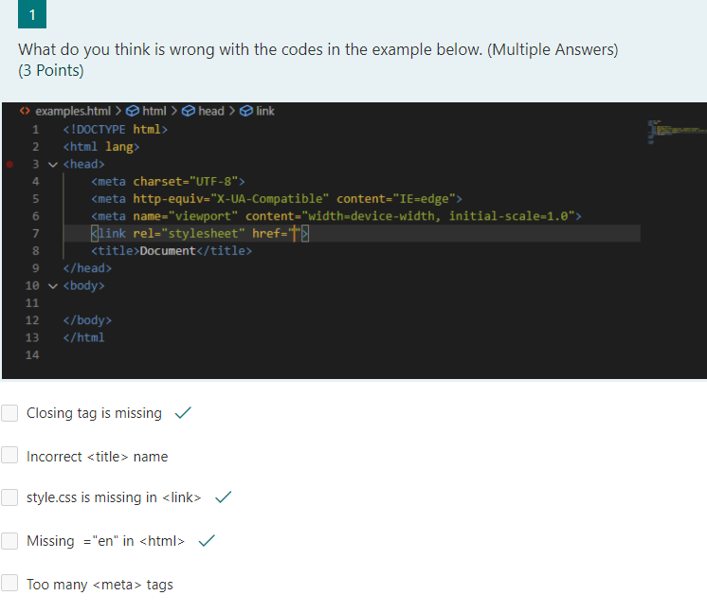

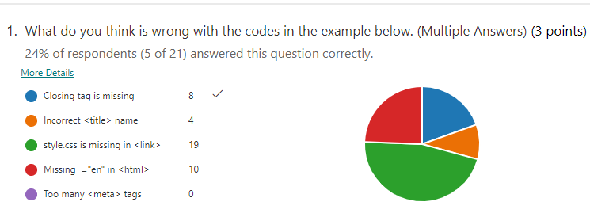

**Question 5**

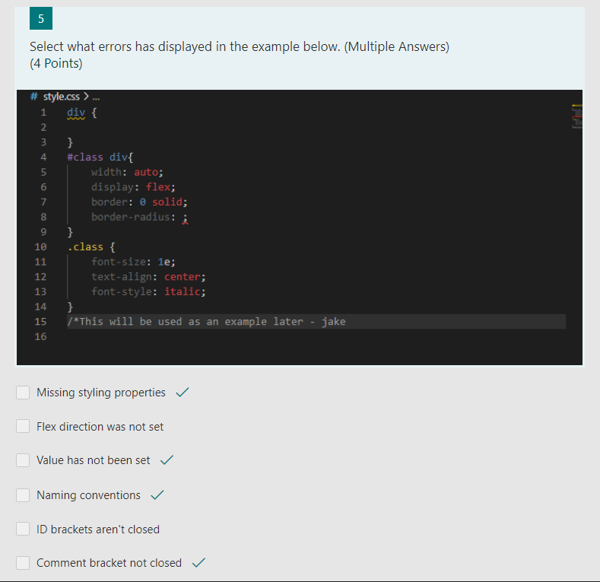

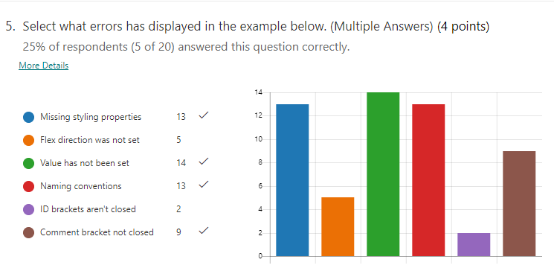

# Content Structure

**List of pages**

* Home (index.html)
* Team Biography (team-bio.html)
* About HTML (information-html.html)
* About CSS (information-css.html)
* Questionnaire (questionnaire.html)

**Type of content**

Home (index.html):

* It has three contents within the main container and each content with a clickable image leads to another page which is About HTML, About CSS and Team Biography page.
* Footer which has a link that directs to TU Dublin website.

Team Biography (team-bio.html)

* It has two contents within the main container with each content with a biography of our team members Jake and Matthew.
* Footer which has a link that directs to TU Dublin website.

About HTML (information-html.html)

* In the About HTML page, it has 4 contents explaining about the HTML, one content appointed as a menu to link to specific part of the page and one content with an image of the code related to HTML at the top of the page.
* In Media Screen, the content changes colour.
* Footer which has a link that directs to TU Dublin website.

About CSS (information-css.html)

* In the About CSS page, it has 4 contents explaining about the CSS with one content appointed a menu to link to a specific part of the page and one content with an image of the CSS code at the top of the page.
* In Media Screen, the contents have been displayed invisible with added content displayed explaining how flexible CSS can be.
* Footer which has a link that directs to TU Dublin website.

Questionnaire (questionnaire.html)

* It has a questionnaire content asking if they learned anything about the website and contact us content.
* Footer which has a link which directs it to the HTML and CSS Quiz.

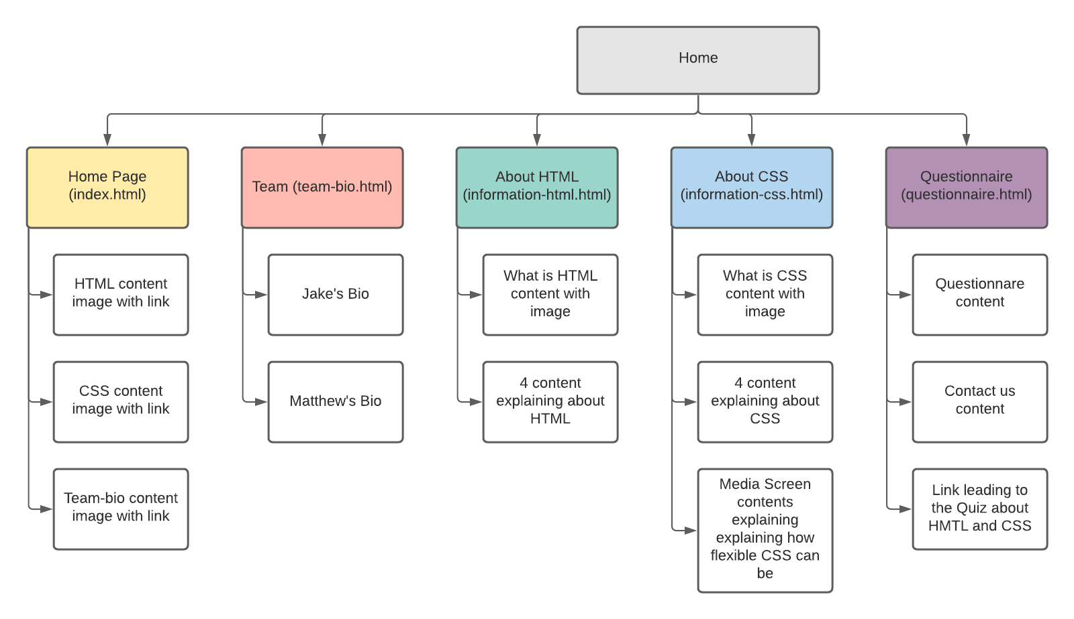

# Design

**Colours:**

* #4894f7
* #0000ff
* #00ffff
* #000000
* #808080
* #8fc9ff
* #ffffff
* #6495ed
* #ffd700
* df99f
* 3b38f3
* 74aaf0
* 00ff00
* 13E2DA

**Font:**

* Font Family: Courier, monospace
* Font Sizes: Medium, Default

|  |  |
| --- | --- |
| **HTML Tags** | **CSS Selectors, Classes, IDs** |
| <head> | body |
| <title> | nav |
| <body> | nav ul |
| <ul>,<ol>,<li> | nav a:visited |
| <a> | Nav a:hover |
| <nav> | Nav a:active |
| <div> | Nav a.current |
| <section> | Section |
| <h2><h3> | footer |
| <p> | img |
| <dl>, <dt>, <dd> | Img:hover.link |
| <footer> | Img.profile |
| <img> | .mainContainer |
| <strong> | .content |
| <I> | .content-2 |
| <form> | .content-2 a |
|  | .content-2 a:hover |
|  | .content-3 |
|  | .content-4 |
|  | .content-4 a |
|  | .content-4 a:hover |
|  | .h2med |
|  | .row |
|  | #content-text p |
|  | #mainpics |
|  | #menu1 |
|  | #menu2 |
|  | #menu3 |
|  | #menu4 |
|  | #logo |
|  | #list_type |
|  | #randomcolorA |
|  | #randomcolorB |
|  | @media only screen and (max-width: 700px) |
|  | .sizeable-content |
|  | .sizeable-content:hover |
|  | .sizeable-content:hover.content height-1 |
|  | .sizeable-content:hover.content height-2 |
|  | .submit-button |

**Previous Version/Layout Design:**

**Previous Iteration of Team’s.HTML Page**

**Previous iteration of Information-pages**

# Accessibility

**Style consideration**

* We made the website easy to read with a few technical terms.
* There is not a lot of text or boxes of contents to look around for.
* We have included mobile support for anyone using their phone to browse on our website.
* We have used the Microsoft standard colours for our website so it easy to visually read on our website without any conflicting colours.

**Style Sheet**

* Only one style sheet has been used for the entirety of the website.

**Accessibility for disabled users**

* We have not included easy access for people with visual and audio impairment but will take into consideration for future projects.
* <https://www.w3.org/WAI/standards-guidelines/wcag/>

# Browser and Device Support

**Browser**

* Google Chrome, Mozilla Firefox, Microsoft Edge and Opera.

**Devices**

* IOS devices and Android devices